Software Project Management Plan (SPMP)

**INTRODUCTION**

**1.1 Project Overview**

This project entails developing and building a website to help pregnant mothers educate themselves on how their symptoms could potentially lead to pregnancy complications. The website will have a database that will help mothers go through their symptoms and provide some answers or solutions or maybe refer you to a doctor. Looking ahead, the website should be especially compatible with mobile devices and will later be developed into an app similar to a health or period app.

**1.2 Project Deliverables**

     **See Gantt Chart for more detailed information

1. Use Cases – due 3/31/20
2. Requirements – due 3/31//20
3. Software project management proposal – due 2/25/20
4. First website prototype - 4/4/20
5. Finalize website/launched version – 4/18/20

**1.3 Evolution of SPMP**

N/A

**1.4 Reference materials**

<https://www.computerhope.com/jargon/s/server.htm>

<https://cs.uwaterloo.ca/~apidduck/se362/Assignments/A2/spmp.pdf>

<https://existek.com/blog/sdlc-models/>

<https://www.softwaretestinghelp.com/software-development-life-cycle-sdlc/>

**1.5 Definitions and Acronyms**

API - Applications Programming Interface

Domain - the location of awebsite

Host - a computer or another device connected to a computer network

Server - a software or hardware device that accepts and responds to requests made over a network

**PROJECT ORGANIZATION**

**2.1 Process Model**

The process model used for this project will be an agile model; this model has several phases where each phase depends on the deliverables of the previous one. The agile development life cycle follow the following order: Concept, Inception, Construction, Release, Production, Retirement. Each process may be repeated as necessary.

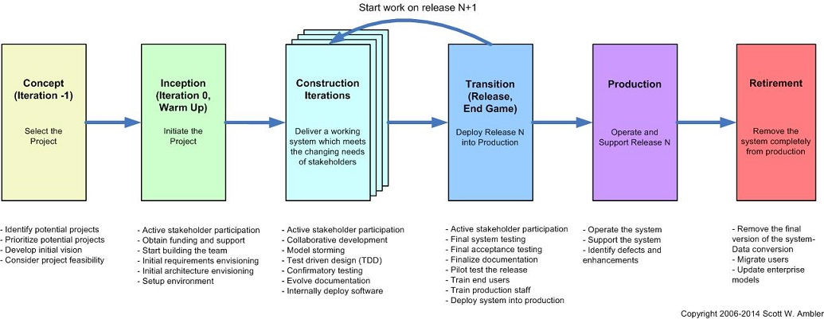

<http://www.ambysoft.com/essays/agileLifecycle.html>



**2.2 Organizational Structure**

    There is a limited organizational structure for this project. The project is affiliated with the organization called the American Pregnancy Association. I will be completing all portions of this project individually with the support of the professor.

**2.3 Project Responsibilities**

|  |  |  |
| --- | --- | --- |
| Role | Description | Person(s) |
| Project Manager | Handles the communications with professor | Adamma |
| Planner/documentation | Competes the various deliverables that are required by the client | Adamma |
| Programmer | Completes the programming tasks for project | Adamma |

**MANAGERIAL PROCESS**

**3.1 Management Objectives and Priorities**

|  |  |  |  |
| --- | --- | --- | --- |
| Project Dimension | Fixed | Constrained | Flexible |
| Cost |  | X |  |
| Schedule | X |  |  |
| Scope/Functionality |  |  | X |

**3.2 Assumptions, Dependencies, and Constraints**

Constraints:

1. There is a constraint on the budget; this project is for a client with no public funding. The primary source of money comes from donations, crowd funding and advertising profits.
2. There is a constraint on time; we have a few months to complete the project. The project will be due in the month of May.

Dependencies:

1. We will be dependent and rely on the server, hosting service, and certain APIs we may use.

Assumptions:

1. The functionality of the website may be limited given the time frame.
2. The website may not be fully finished. It will be in a beta stage of development.

**3.3 Risk Management Concerns**

    Risk 1: What happens if the web server crashes?

Risk 2: What happens if there is an issue with host service?

**3.4 Risk Management Solutions**

Solution1: In order to reduce risks files will be downloaded to an external hard drive once a week

**3.5 Monitoring and Controlling Mechanisms**

    N/A

**3.6 Staffing Approach**

    N/A

**TECHNICAL PROCESS**

**4.1 Methods, Tools, and Techniques**

The agile model shall be used for this software project. Tools to be used include Github, HTML, CSS and AWS (Possibly using JavaScript (using libraries like React)).

**4.2 Software Documentation**

I will document the major sections of each file. Comments will be documented throughout code. I will also document any errors complications in a separate file for easy reference, in case I will need to refer back to resolve any future issues or bugs.

**4.3 User Documentation**

I will provide documentation in the form of an FAQs section.

**4.4 Project Support Functions**

I will follow the steps of a basic configuration management plan; in the event I will need to make change or updates during the course of development. Steps of a CMP include, define, document, control, implement, account for, and audit changes to the project.

**WORK ELEMENTS, SCHEDULE, AND BUDGET**

**5.1 Work Breakdown Structure**

